Machine Learning

Machine Learning is said as a subset of **artificial intelligence** that is mainly concerned with the development of algorithms which allow a computer to learn from the data and past experiences on their own. The term machine learning was first introduced by **Arthur Samuel** in **1959**. We can define it in a summarized way as:

Machine learning enables a machine to automatically learn from data, improve performance from experiences, and predict things without being explicitly programmed.

With the help of sample historical data, which is known as **training data**, machine learning algorithms build a **mathematical model** that helps in making predictions or decisions without being explicitly programmed. Machine learning brings computer science and statistics together for creating predictive models. Machine learning constructs or uses the algorithms that learn from historical data. The more we will provide the information, the higher will be the performance.

**A machine has the ability to learn if it can improve its performance by gaining more data.**

How does Machine Learning work

A Machine Learning system **learns from historical data, builds the prediction models, and whenever it receives new data, predicts the output for it**. The accuracy of predicted output depends upon the amount of data, as the huge amount of data helps to build a better model which predicts the output more accurately.

Suppose we have a complex problem, where we need to perform some predictions, so instead of writing a code for it, we just need to feed the data to generic algorithms, and with the help of these algorithms, machine builds the logic as per the data and predict the output. Machine learning has changed our way of thinking about the problem. The below block diagram explains the working of Machine Learning algorithm:

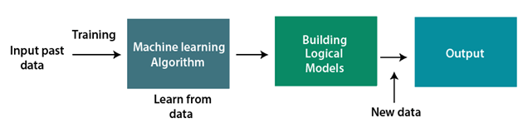

Features of Machine Learning:

* Machine learning uses data to detect various patterns in a given dataset.
* It can learn from past data and improve automatically.
* It is a data-driven technology.
* Machine learning is much similar to data mining as it also deals with the huge amount of the data.

Need for Machine Learning

The need for machine learning is increasing day by day. The reason behind the need for machine learning is that it is capable of doing tasks that are too complex for a person to implement directly. As a human, we have some limitations as we cannot access the huge amount of data manually, so for this, we need some computer systems and here comes the machine learning to make things easy for us.

We can train machine learning algorithms by providing them the huge amount of data and let them explore the data, construct the models, and predict the required output automatically. The performance of the machine learning algorithm depends on the amount of data, and it can be determined by the cost function. With the help of machine learning, we can save both time and money.

The importance of machine learning can be easily understood by its uses cases, Currently, machine learning is used in **self-driving cars**, **cyber fraud detection**, **face recognition**, and **friend suggestion by Facebook**, etc. Various top companies such as Netflix and Amazon have build machine learning models that are using a vast amount of data to analyze the user interest and recommend product accordingly.

**Following are some key points which show the importance of Machine Learning:**

* Rapid increment in the production of data
* Solving complex problems, which are difficult for a human
* Decision making in various sector including finance
* Finding hidden patterns and extracting useful information from data.

Classification of Machine Learning

At a broad level, machine learning can be classified into three types:

1. **Supervised learning**
2. **Unsupervised learning**
3. **Reinforcement learning**

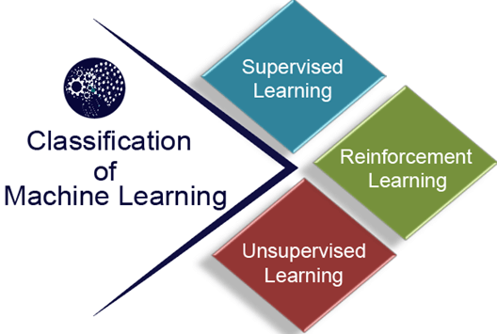

### **1) Supervised Learning**

Supervised learning is a type of machine learning method in which we provide sample labeled data to the machine learning system in order to train it, and on that basis, it predicts the output.

The system creates a model using labeled data to understand the datasets and learn about each data, once the training and processing are done then we test the model by providing a sample data to check whether it is predicting the exact output or not.

The goal of supervised learning is to map input data with the output data. The supervised learning is based on supervision, and it is the same as when a student learns things in the supervision of the teacher. The example of supervised learning is **spam filtering**.

Supervised learning can be grouped further in two categories of algorithms:

* **Classification**
* **Regression**

### **2) Unsupervised Learning**

Unsupervised learning is a learning method in which a machine learns without any supervision.

The training is provided to the machine with the set of data that has not been labeled, classified, or categorized, and the algorithm needs to act on that data without any supervision. The goal of unsupervised learning is to restructure the input data into new features or a group of objects with similar patterns.

In unsupervised learning, we don't have a predetermined result. The machine tries to find useful insights from the huge amount of data. It can be further classifieds into two categories of algorithms:

* **Clustering**
* **Association**

### **3) Reinforcement Learning**

Reinforcement learning is a feedback-based learning method, in which a learning agent gets a reward for each right action and gets a penalty for each wrong action. The agent learns automatically with these feedbacks and improves its performance. In reinforcement learning, the agent interacts with the environment and explores it. The goal of an agent is to get the most reward points, and hence, it improves its performance.

The robotic dog, which automatically learns the movement of his arms, is an example of Reinforcement learning.

# **Applications of Machine learning**

Machine learning is a buzzword for today's technology, and it is growing very rapidly day by day. We are using machine learning in our daily life even without knowing it such as Google Maps, Google assistant, Alexa, etc. Below are some most trending real-world applications of Machine Learning:

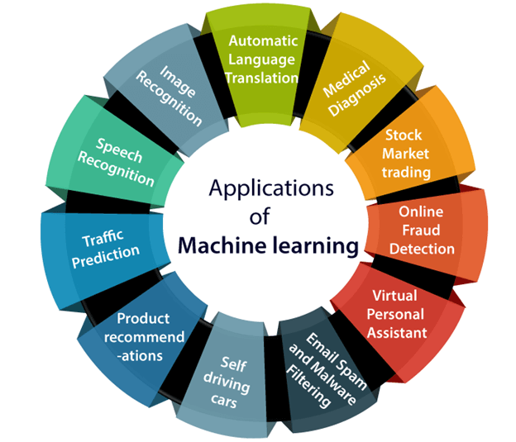

# **Machine learning Life cycle**

Machine learning has given the computer systems the abilities to automatically learn without being explicitly programmed. But how does a machine learning system work? So, it can be described using the life cycle of machine learning. Machine learning life cycle is a cyclic process to build an efficient machine learning project. The main purpose of the life cycle is to find a solution to the problem or project.

Machine learning life cycle involves seven major steps, which are given below:

* **Gathering Data**
* **Data preparation**
* **Data Wrangling**
* **Analyse Data**
* **Train the model**
* **Test the model**
* **Deployment**

The most important thing in the complete process is to understand the problem and to know the purpose of the problem. Therefore, before starting the life cycle, we need to understand the problem because the good result depends on the better understanding of the problem.

In the complete life cycle process, to solve a problem, we create a machine learning system called "model", and this model is created by providing "training". But to train a model, we need data, hence, life cycle starts by collecting data.

## 1. Gathering Data:

Data Gathering is the first step of the machine learning life cycle. The goal of this step is to identify and obtain all data-related problems.

In this step, we need to identify the different data sources, as data can be collected from various sources such as **files**, **database**, **internet**, or **mobile devices**. It is one of the most important steps of the life cycle. The quantity and quality of the collected data will determine the efficiency of the output. The more will be the data, the more accurate will be the prediction.

This step includes the below tasks:

* **Identify various data sources**
* **Collect data**
* **Integrate the data obtained from different sources**

By performing the above task, we get a coherent set of data, also called as a **dataset**. It will be used in further steps.

## 2. Data preparation

After collecting the data, we need to prepare it for further steps. Data preparation is a step where we put our data into a suitable place and prepare it to use in our machine learning training.

In this step, first, we put all data together, and then randomize the ordering of data.

This step can be further divided into two processes:

* **Data exploration:**  
  It is used to understand the nature of data that we have to work with. We need to understand the characteristics, format, and quality of data.  
  A better understanding of data leads to an effective outcome. In this, we find Correlations, general trends, and outliers.
* **Data pre-processing:**  
  Now the next step is preprocessing of data for its analysis.

## 3. Data Wrangling

Data wrangling is the process of cleaning and converting raw data into a useable format. It is the process of cleaning the data, selecting the variable to use, and transforming the data in a proper format to make it more suitable for analysis in the next step. It is one of the most important steps of the complete process. Cleaning of data is required to address the quality issues.

It is not necessary that data we have collected is always of our use as some of the data may not be useful. In real-world applications, collected data may have various issues, including:

* **Missing Values**
* **Duplicate data**
* **Invalid data**
* **Noise**

So, we use various filtering techniques to clean the data.

It is mandatory to detect and remove the above issues because it can negatively affect the quality of the outcome.

## 4. Data Analysis

Now the cleaned and prepared data is passed on to the analysis step. This step involves:

* **Selection of analytical techniques**
* **Building models**
* **Review the result**

The aim of this step is to build a machine learning model to analyze the data using various analytical techniques and review the outcome. It starts with the determination of the type of the problems, where we select the machine learning techniques such as **Classification**, **Regression**, **Cluster analysis**, **Association**, etc. then build the model using prepared data, and evaluate the model.

Hence, in this step, we take the data and use machine learning algorithms to build the model.

## 5. Train Model

Now the next step is to train the model, in this step we train our model to improve its performance for better outcome of the problem.

We use datasets to train the model using various machine learning algorithms. Training a model is required so that it can understand the various patterns, rules, and, features.

## 6. Test Model

Once our machine learning model has been trained on a given dataset, then we test the model. In this step, we check for the accuracy of our model by providing a test dataset to it.

Testing the model determines the percentage accuracy of the model as per the requirement of project or problem.

## 7. Deployment

The last step of machine learning life cycle is deployment, where we deploy the model in the real-world system.

If the above-prepared model is producing an accurate result as per our requirement with acceptable speed, then we deploy the model in the real system. But before deploying the project, we will check whether it is improving its performance using available data or not. The deployment phase is similar to making the final report for a project.